

Year 10 Science

**Earth & Space 2 Test: The Universe**

**SECTION 1: MULTIPLE CHOICE** (1 mark each)

Circle your answer on the multiple choice answer sheet.

1. Which is the correct order from smallest to largest?
   1. Moon, star, planet, asteroid.
   2. Moon, planet, galaxy, universe.
   3. Comet, meteor, galaxy, star.
   4. Sun, moon, galaxy, universe.
2. The Big Bang Theory describes the origin of the universe as ‘singularity’. Singularity consisted of
   1. zero mass
   2. zero energy
   3. zero volume
   4. zero density
3. The first fundamental interaction in the universe was
   1. gravitational
   2. electrostatic
   3. weak
   4. strong
4. Which of the following was true about the expanding universe?
   1. Its average temperature has been increasing.
   2. Its average density has been decreasing.
   3. The amount of energy has been increasing.
   4. The amount of matter has been decreasing.
5. Which of the following is true about the Big Bang Theory?
   1. Galaxies are moving apart from each other as the universe expands.
   2. Stars are being thrown apart from each other due to the momentum of a past explosion.
   3. The universe suddenly appeared in space.
   4. The Big Bang attempts to explain why the universe was created, what existed before the universe and what exists outside of the universe.
6. Which is the correct sequence of events?
   1. formation of stars, formation of galaxies, formation of matter, formation of solar systems, humans appeared on Earth
   2. formation of galaxies, formation of stars, formation of matter, formation of solar systems, humans appeared on Earth
   3. formation of matter, formation of stars, formation of galaxies, formation of solar systems, humans appeared on Earth
   4. formation of solar systems, humans appeared on Earth, formation of stars, formation of galaxies, formation of matter
7. Which of the following is not evidence for the Big Bang Theory?
   1. The universe continues to expand, as measured using Doppler Effect and spectral shift analysis.
   2. There is an abundance of hydrogen and helium, the first two elements to exist in the universe, at levels predicted by Big Bang Theorists.
   3. Cosmic microwave radiation exists uniformly in the universe as background radiation, at levels predicted by the Big Bang theorists.
   4. The Square Kilometre Array has detected hadrons and measured gravity waves which show the existence of black holes, as predicted by Big Bang Theorists.
8. In spectral analysis of stars, red shift occurs
   1. as apparent wavelength increases.
   2. as a star moves towards us.
   3. as apparent frequency increases.
   4. as apparent temperature increases.
9. The source of energy for our star is
   1. nuclear fission of helium to form hydrogen.
   2. nuclear fusion of hydrogen to form helium
   3. combustion of hydrogen and helium
   4. nucleosynthesis of protons and neutrons to form hydrogen
10. Our sun is a medium star. It will become all of the following during its lifetime, except a
    1. red giant.
    2. planetary nebula
    3. white dwarf
    4. neutron star
11. Which is the correct sequence for the life cycle a very large star
    1. Stellar nebula 🡪 massive star 🡪 red hypergiant 🡪 supernova 🡪 black hole
    2. Planetary nebula 🡪 White dwarf 🡪 red hypergiant 🡪 supernova 🡪 Pulsar
    3. Stellar nebula 🡪 massive star 🡪 red hypergiant 🡪 supernova 🡪 Planetary nebula
    4. Stellar nebula 🡪 massive star 🡪 blue ghost giant 🡪 supernova 🡪 black hole
12. The Large Hadron Collider was built by CERN, the European Organisation for Nuclear Research, between 1998 and 2008, at a cost of US$6 billion, to allow physicists to test their predictions of different theories of particle physics and search for new particles as predicted by supersymmetry, one of several new theories to evolve from Big Bang Theory and the Standard Model. Which of the following statements about the Large Hadron Collider is true?
    1. It was built in Japan.
    2. It is the largest machine in the world.
    3. It orbits approximately 400 km above the Earth at a speed of 27,600 km/hr.
    4. It has been running continuously since 2008.

Examine the Hertzsprung-Russell Diagram and then answer the questions below

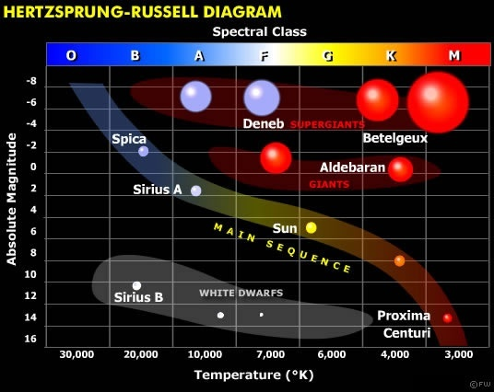

1. What is the absolute magnitude of a white dwarf?
   1. 2
   2. 14
   3. 7,000
   4. 10,000
2. Which of these stars is in the M spectral class?
   1. Aldebaran
   2. Proxima Centauri
   3. Betelgeux
   4. Sirius M
3. Which star would be described as yellow, medium sized, medium temperature and middle aged?
   1. Our sun
   2. Deneb
   3. Sirius A
   4. Spica

END OF TEST